Data Mining SQL Server by Joshua Troup

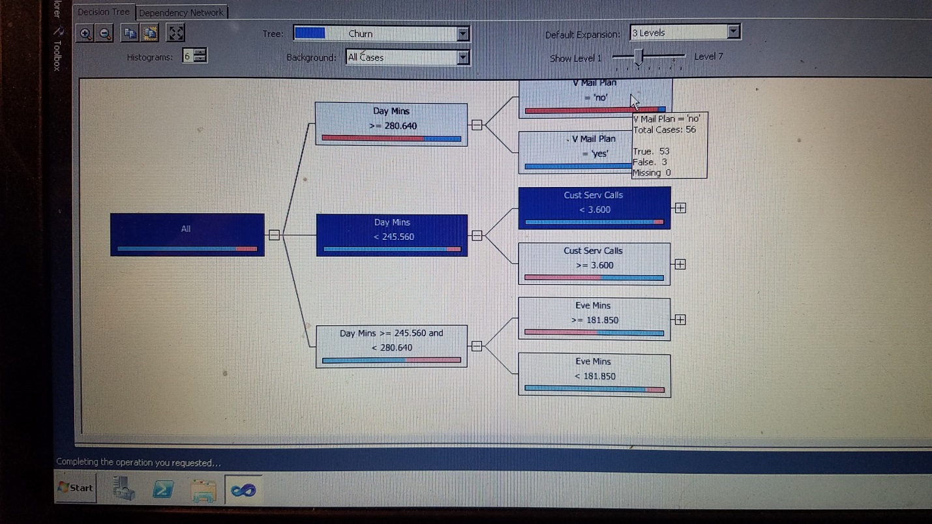

Decision Tree with the Churn data set. One node shows 56 cases which 53 are true and 3 cases false. Day Mins > than 280.64 and also have a Voice Mail Plan are highly likely to churn.

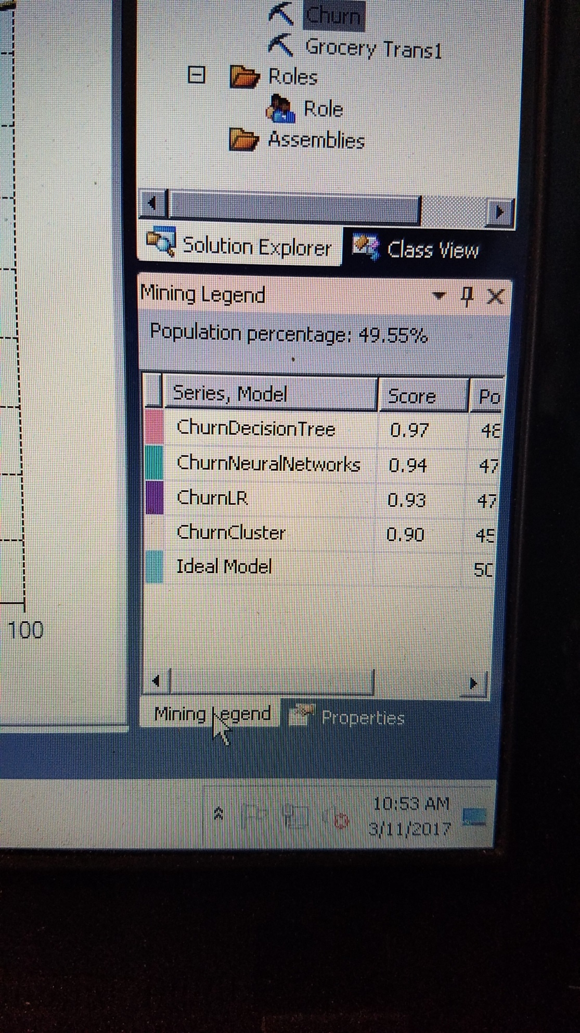

The results above indicate the accuracy for the classifications. Decision Tree is the greatest with a 97% accuracy with three other classifications close behind.

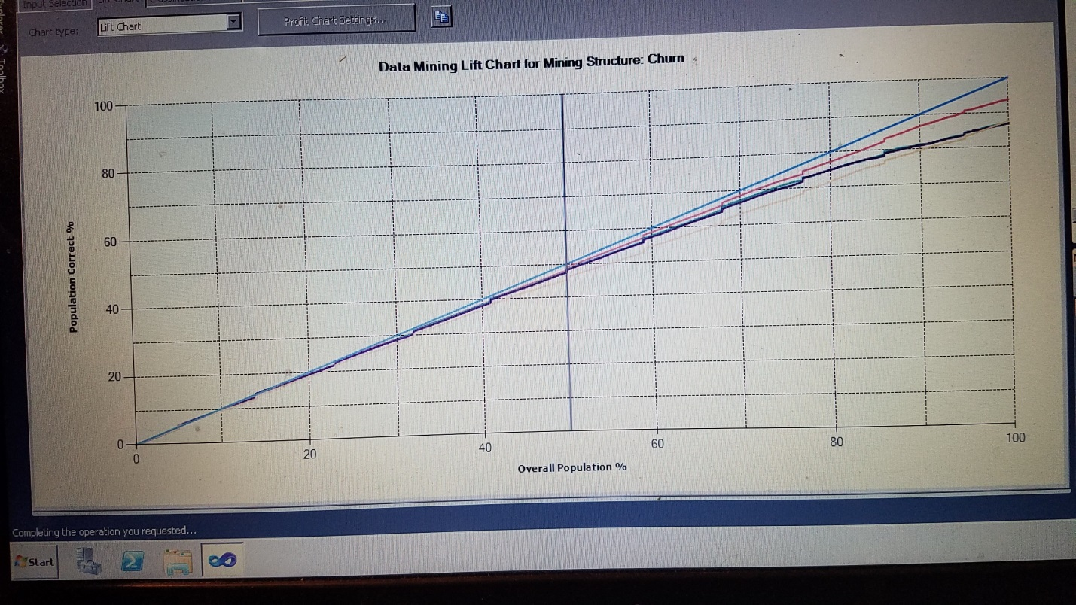

This is the lift chart for the accuracy as shown in picture 2. The accuracy percentage is very close as is shown in the chart.

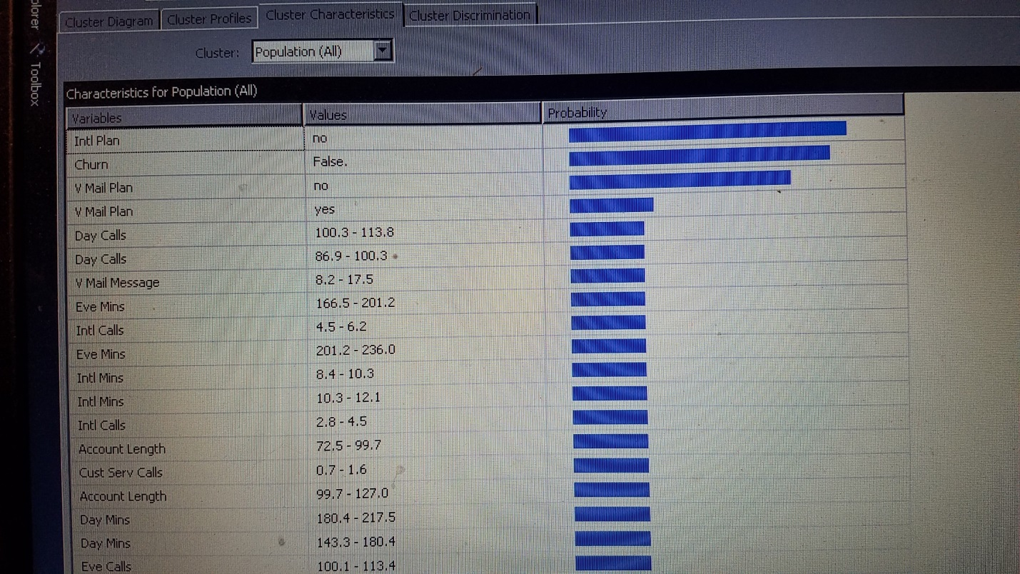

Cluster above indicates the majority of the customers stayed with the telecommunications company and did not churn. Most of the customers did not have a voice mail plan or international plan.

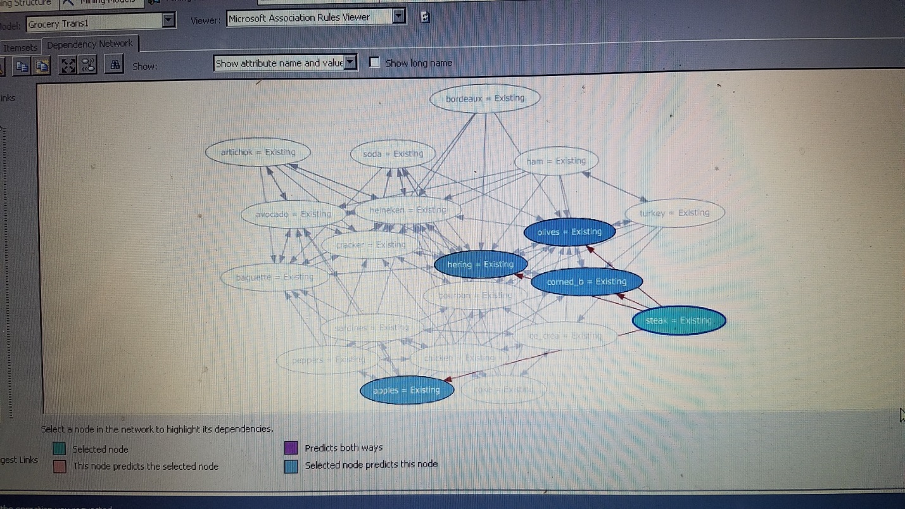

Above shows the Grocery Transaction data set as Association Rules. Steak node was selected to show the strong connection to apples, corned_b, olives, and hering.